[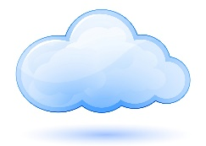](http://www.google.com/url?sa=i&rct=j&q=&esrc=s&source=images&cd=&cad=rja&uact=8&ved=0ahUKEwjrgdec2pPMAhVHlB4KHVcNCXcQjRwIBw&url=http://qbyteit.com/2016/02/28/what-in-the-hell-is-the-cloud/&psig=AFQjCNFv1vbSOAm39aa74L12CFf9aoUfBg&ust=1460914889035579)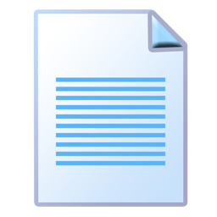

**Cloud Based Mobile Document Management System**

The cloud based document management system is designed to provide integration, mobility, and flexibility to the current Newport News Shipbuilding’s document management system. By utilizing the cloud infrastructure, users are no longer tethered to the desktops. All documents will be accessible from any location at any time on any device. By capturing static documents and digitizing them, we can upload them to the cloud so that they are available for viewing, downloading and editing.

In utilizing this app, Newport News shipbuilding will be able save time, money and greatly improve the user’s experience. No longer with they be required to carry large drawings and documents to different locations. They simply take a picture, upload the image and the App does the rest.